# Setup of Kali on Raspberry Pi 400 with Pi Imager

Last Update: 18 Jan 2022

These directions are how the Kali OS were configured using the Raspberry Pi 400.

1. Download and installed the Raspberry Pi Imager at [https://www.raspberrypi.org/downloads.../](https://nam04.safelinks.protection.outlook.com/?url=https%3A%2F%2Fwww.raspberrypi.org%2Fdownloads...%2F&data=04%7C01%7Cshannon.beck%40afacademy.af.edu%7C3fbea1cc99964810579208d9c6945f6d%7C7ab80a06f02945c084d17dad19ce3c61%7C0%7C0%7C637759162837809522%7CUnknown%7CTWFpbGZsb3d8eyJWIjoiMC4wLjAwMDAiLCJQIjoiV2luMzIiLCJBTiI6Ik1haWwiLCJXVCI6Mn0%3D%7C3000&sdata=13SaZr1Q4dFTbxP4ZvGkRzE84YQtooond%2B7vA3TAT4w%3D&reserved=0). Chose the correct OS for your host system. I worked from Windows.
2. Download the 32-bit version of Kali for the RPi 400 under ARM images. [https://www.offensive-security.com/kali-linux-arm-images/](https://nam04.safelinks.protection.outlook.com/?url=https%3A%2F%2Fwww.offensive-security.com%2Fkali-linux-arm-images%2F&data=04%7C01%7Cshannon.beck%40afacademy.af.edu%7C3fbea1cc99964810579208d9c6945f6d%7C7ab80a06f02945c084d17dad19ce3c61%7C0%7C0%7C637759162837809522%7CUnknown%7CTWFpbGZsb3d8eyJWIjoiMC4wLjAwMDAiLCJQIjoiV2luMzIiLCJBTiI6Ik1haWwiLCJXVCI6Mn0%3D%7C3000&sdata=tDc93lZSgZjs55Vo8PFTVCYiCjjDusBKPLvOvlwx4qI%3D&reserved=0). If you are not sure which processor you have, run the "uname -m" command and it should show you this information. When I ran it on my RPi 400 using the default operating system (Raspberry Pi OS) that came with it, the command shows that it is an ARM processor version 7:
   1. pi@Pi400SB:~ $ uname -m
   2. armv7l

More information about choosing the correct Kali Linux download is at [https://www.kali.org/docs/introduction/download-official-kali-linux-images/](https://nam04.safelinks.protection.outlook.com/?url=https%3A%2F%2Fwww.kali.org%2Fdocs%2Fintroduction%2Fdownload-official-kali-linux-images%2F&data=04%7C01%7Cshannon.beck%40afacademy.af.edu%7C3fbea1cc99964810579208d9c6945f6d%7C7ab80a06f02945c084d17dad19ce3c61%7C0%7C0%7C637759162837809522%7CUnknown%7CTWFpbGZsb3d8eyJWIjoiMC4wLjAwMDAiLCJQIjoiV2luMzIiLCJBTiI6Ik1haWwiLCJXVCI6Mn0%3D%7C3000&sdata=amiBIvbHDGegAe4ATooB%2BZ3MXfA6lWwTWrUXIEmxJhQ%3D&reserved=0).

1. Open the Raspberry Pi Imager from the Windows host machine (or other OS you are using).
2. Chose "Erase" - Selected memory card - Clicked on Write - took a few minutes to erase. Note: don’t skip this step–it can cause problems later. 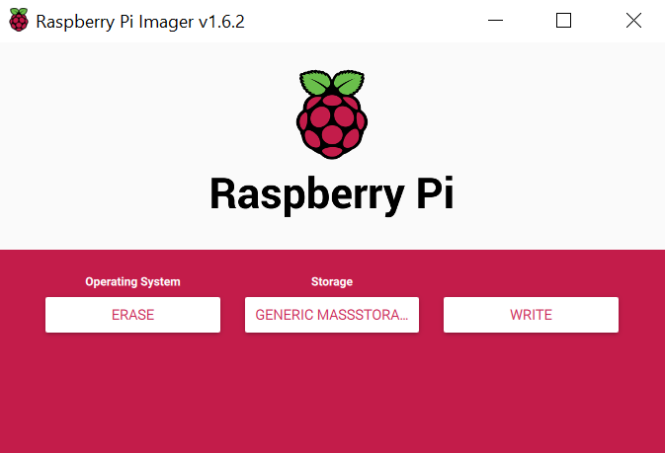
3. From the RPi Imager on the Windows host machine:
   1. Chose "Custom" and select downloaded Kali image for ARM image (kali-linux-…-armhf.img.xz) downloaded in Step 2.
   2. Under “Storage,” select the memory card to write to.
   3. Click on Write. This can take about 10 minutes or longer to write the Kali image to the card.

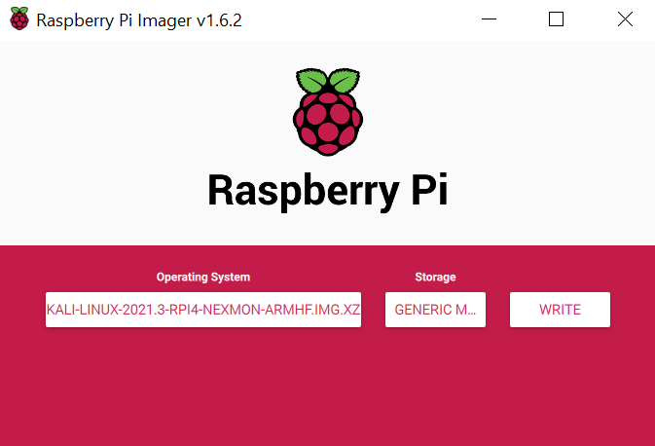

1. Insert memory card into the back of the RPi 400. If there is a memory card already inserted, remove other memory card by pushing in and popping out the microSD card. Push this written microSD memory card in until the card “locks” in.

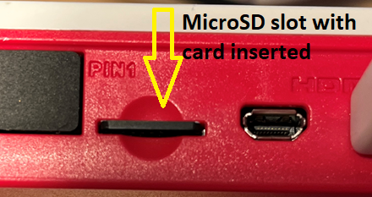

1. Plug in the RPi 400 into a monitor using the included MicroHDMI cable.
2. Plug in the mouse into any of the USB slots.
3. Last, plug in the USB-C power into the power slot (has on/off power logo above it).
4. Watch Kali boot and a lot of text will go by. This is normal.
5. When the login screen comes up log in:
   1. username: kali
   2. password: kali
6. Setup network: connect an Ethernet cable or select the Wi-Fi signal in the upper right corner near the clock. For wi-fi: Choose the appropriate network and login credentials to get online.
7. Update the system files and programs. Note: this can take 20 minutes or more.
   1. Open a terminal window:

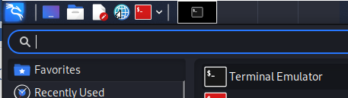

* 1. sudo apt update

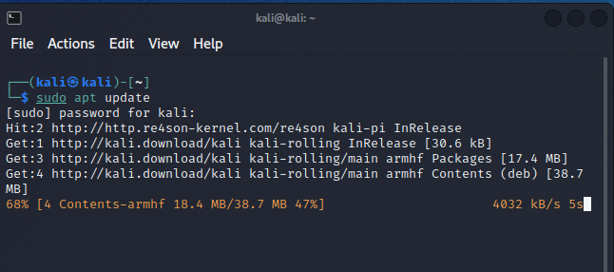

* 1. sudo apt upgrade

Note: If prompted for the password, use "kali".

1. Run through the "**sudo apt update**" and the "**sudo apt upgrade**" 2-3 times.
2. Run “**sudo apt autoremove**” to cleanup unneeded program files.
3. (Optional) For remote access, run the commands to enable remote desktop access (a “headless” node), run the following commands:
   1. sudo apt install xrdp
   2. sudo systemctl enable xrdp
   3. sudo systemctl start xrdp
4. (Optional) Now is a good time to back up MicroSD card onto the host computer if 32GB is available. Make a full bitwise image of the card using the Win32DiskImager program ([https://sourceforge.net/projects/win32diskimager/](https://nam04.safelinks.protection.outlook.com/?url=https%3A%2F%2Fsourceforge.net%2Fprojects%2Fwin32diskimager%2F&data=04%7C01%7Cshannon.beck%40afacademy.af.edu%7C3fbea1cc99964810579208d9c6945f6d%7C7ab80a06f02945c084d17dad19ce3c61%7C0%7C0%7C637759162837809522%7CUnknown%7CTWFpbGZsb3d8eyJWIjoiMC4wLjAwMDAiLCJQIjoiV2luMzIiLCJBTiI6Ik1haWwiLCJXVCI6Mn0%3D%7C3000&sdata=%2FyOIqBGo4GTsUn7%2Fww%2BTIM05ulhd1k7LMqy4Msh30co%3D&reserved=0)) following the directions at [https://www.howtogeek.com/341944/how-to-clone-your-raspberry-pi-sd-card-for-foolproof-backup/](https://nam04.safelinks.protection.outlook.com/?url=https%3A%2F%2Fwww.howtogeek.com%2F341944%2Fhow-to-clone-your-raspberry-pi-sd-card-for-foolproof-backup%2F&data=04%7C01%7Cshannon.beck%40afacademy.af.edu%7C3fbea1cc99964810579208d9c6945f6d%7C7ab80a06f02945c084d17dad19ce3c61%7C0%7C0%7C637759162837809522%7CUnknown%7CTWFpbGZsb3d8eyJWIjoiMC4wLjAwMDAiLCJQIjoiV2luMzIiLCJBTiI6Ik1haWwiLCJXVCI6Mn0%3D%7C3000&sdata=8pzbKeGBN2TIO%2BPihtByrymQRvpmdyWSl%2FwO%2BhUHoFE%3D&reserved=0). This can also be accomplished using the "dd" command on a Linux, RPi OS, or Mac host system or with Balena Etcher <https://www.balena.io/etcher/>.

# Remote Access to RPi (Extension and Optional)

For remote access and to run a “headless” RPi – no monitor directly hooked up to the RPi and access via the network:

Configuring the System and getting the RPi IP Address:

1. Log into the RPi at least once with a monitor connected.
2. Run “ifconfig” and look for the wired (eth0) IP address if you plugged in a cable or the wireless network (wlan) if you are running via wi-fi.
3. Copy down the IP address associated with the network interface from the step above.
4. Select one of the following options: graphical interface using remote desktop ~or~ command line interface. See the two sections below for instructions on setup.

## Graphical Interface Remote Desktop (preferred if will be working on Kali without a monitor directly connected to the RPi)

Wouldn’t it be nice to run a graphical program or see a desktop?

You can use Remote Desktop (RDP) for this! Windows comes with RDP built-in and it’s also available on Mac OS. Again, for non-routable addresses (such as those that start with 192.168 and 10.), you must be on the same network for the connection to work.

### From the Kali system, in this case the Raspberry Pi running Kali:

* 1. Open a terminal window:



* 1. Install the package for remote desktop connections to this machine

**sudo apt install xrdp**

* 1. Enable the remote desktop package you installed to turn on

**sudo systemctl enable xrdp**

* 1. Start the XRDP service

**sudo systemctl start xrdp**

* 1. Get the IP address of the system by running **ifconfig** and look for the **inet value** or **inet6 value** that are likely under eth0 if plugged in or wlan0 if using the wireless connector.

**ifconfig**

*Example inet value (IPv4 address): 192.168.1.27*

* 1. Add a user to log into the system – will not allow a superuser (root) account such as the default “kali” account for RDP connections.

**sudo adduser *username***

*Where* ***username*** *you want to create. To create an account such as shannon: use command: sudo adduser shannon*

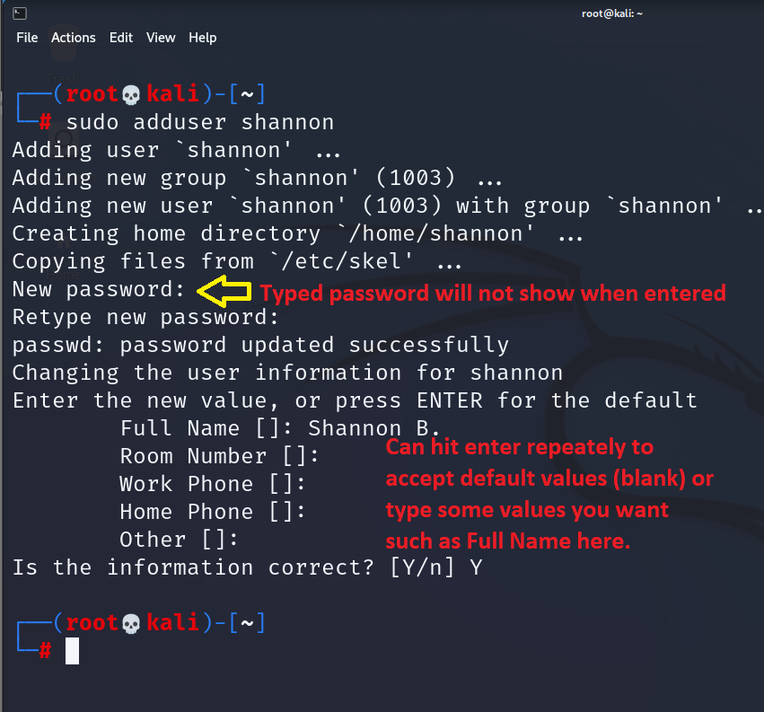Note: the typed password will not show up as you type it. Enter the password and type “Enter”. Repeat to confirm the password. You can hit enter six times to accept the blank values, or you can enter in the information you prefer.

* 1. Check that you added the user correctly. Output the list of users in the /etc/passwd file and search toward the bottom for the newest user.

**cat /etc/passwd**

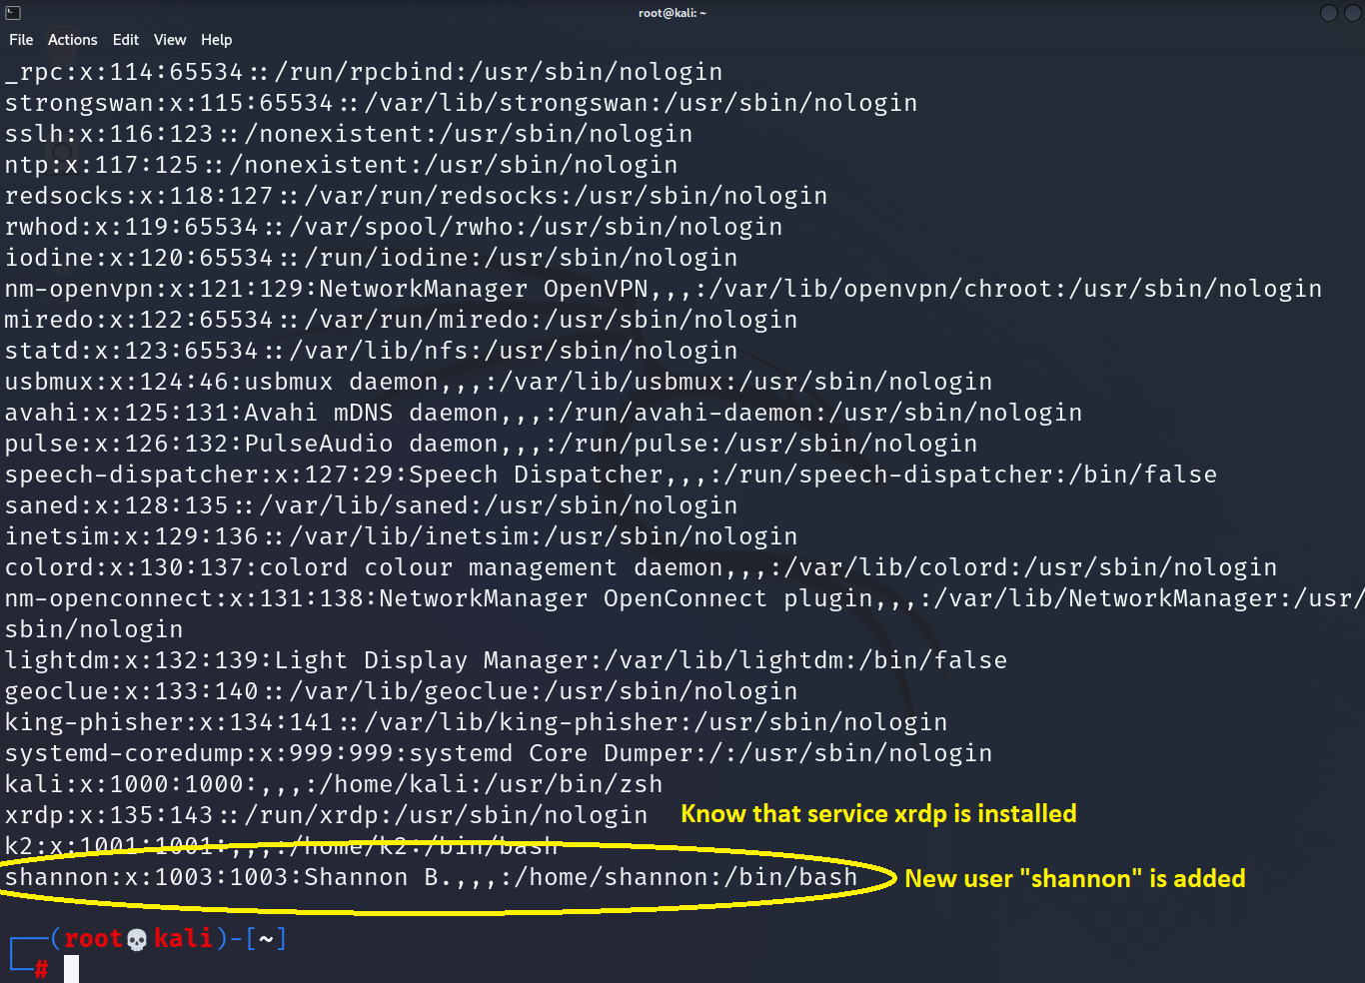

Check for the “xrdp” account as well! That tells the viewer that the remote desktop package we just installed *is* installed.

Note: This \etc\passwd file is great for reconnaissance, showing which user accounts exist and other system information such as services running.

From a Windows system – log into the RPi using the Remote Desktop:

* 1. To connect to the graphical desktop, start the “**Remote Desktop Connection**” program.
  2. Enter the IP address of the RPi and click “**Connect**”

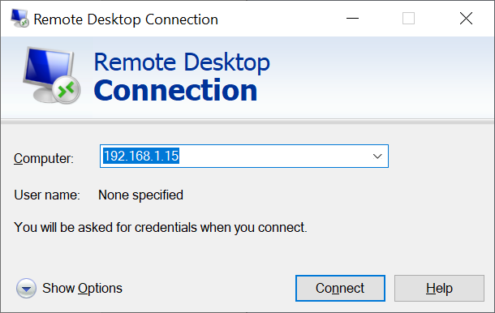

* 1. You might get a warning about the identity of the remote computer cannot be verified, click “**Yes**” to continue.

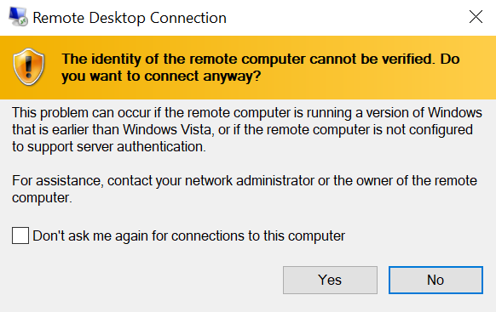

* 1. After a few moments, the logon screen will appear. Use the default “Xorg” Session value from the dropdown box.

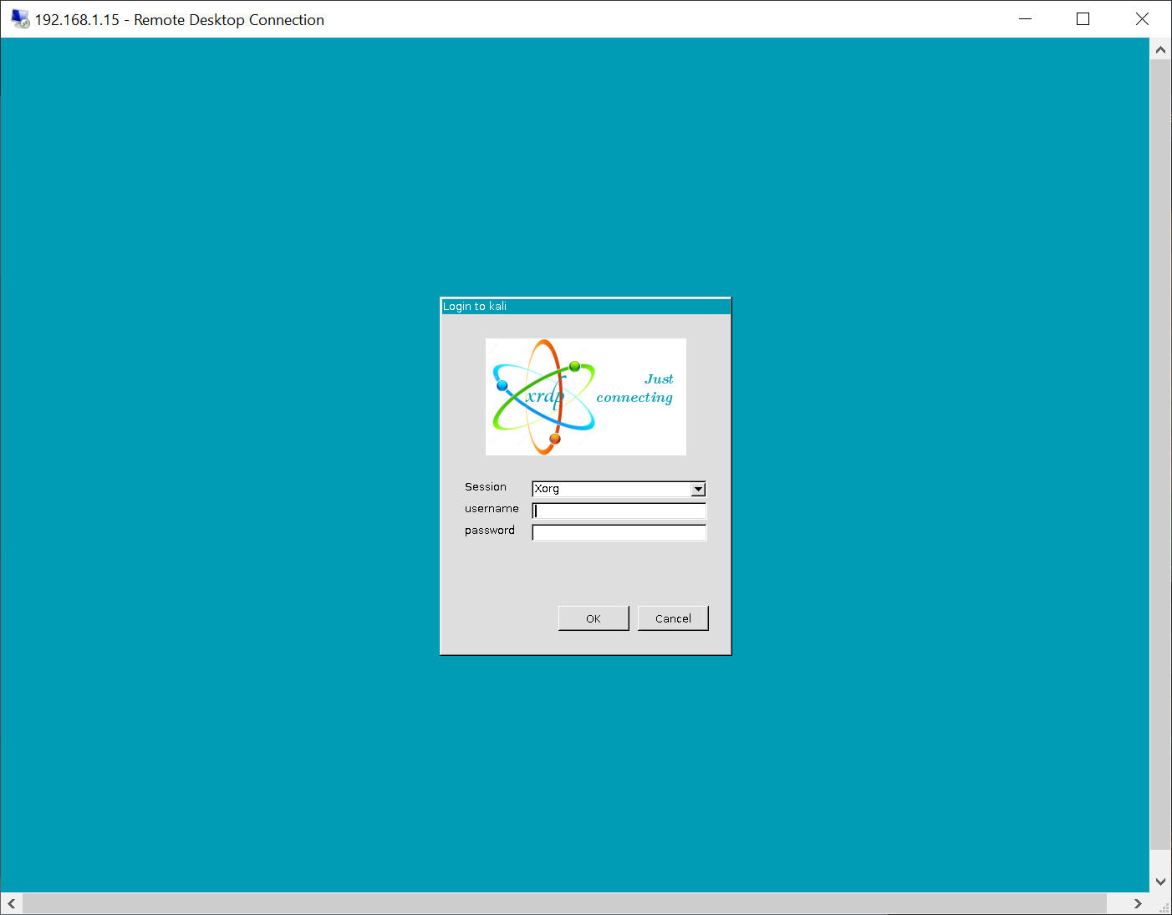

* 1. Log on using the new username and password you created above. In this example the username created is “shannon.”
  2. If successful, the Kali desktop should appear. You might see a box asking for the “kali” account’s password. Enter the password (“kali” is default, you are encouraged to change it to something stronger) and click on “Authenticate.”

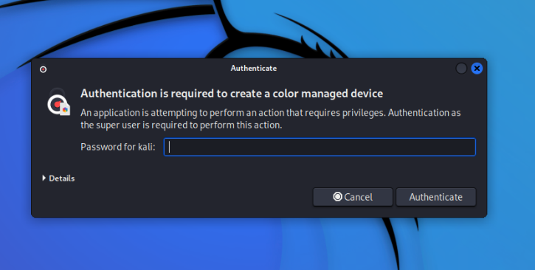

* 1. 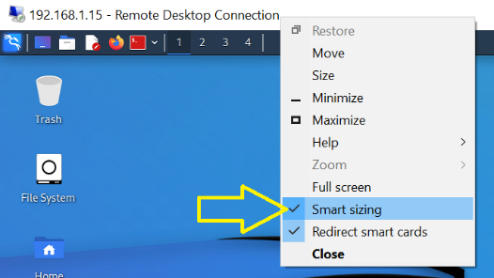 If you want to re-size the RDP window to make it smaller, enable the “Smart sizing.” To do this, move your mouse up to the title bar of the Remote Desktop program and right click. Be sure to have a check mark next to “Smart Sizing” to allow you to change your Kali RDP window size.
  2. When are you finished and ready to shut down RDP you have two options:
     1. Close the RDP window *and* leave the remote session active (all windows open and programs running). You can reconnect to it later through RDP and all of your windows will remain open.
     2. Log out fully and close the session.

For number one – to disconnect a session without closing down the system or logging off, click on the upper right “X” to close the RDP program. You will see a message informing you that “Your remote session will be disconnected.”

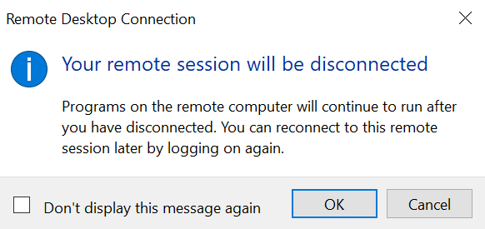

Click OK to disconnect the GUI while keeping everything running remotely. This is ideal for programs that you want to keep running but you don’t need to have an RDP connection.

For number 2: To fully log out when you are done with a session, go to the upper right and click on the power button. 

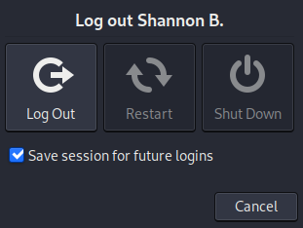And select “Log Out” to both log out of Kali and close the RDP session.

Tips: Only one desktop session can be active at a time. If you are logged in directly on the RPi, you will not be able to connect through the remote desktop (RDP) program. **Be sure to log out of any direct connection before connecting through RDP.**

Input from the article “Enable Remote Desktop with XRDP on Kali Linux” <https://stealthm0de.medium.com/enable-xrdp-on-kali-linux-506980a29d1d>

## Terminal text-only connection (optional)

Connecting the RPI **from a host on the same network:**

* 1. Download and install Putty for remote shell (ssh) access to RPi. <https://www.puttygen.com/download-putty>
  2. Click on “**Session**” in the Category menu.
  3. Enter the Raspberry Pi’s IP address in the Host Name box that you determined through the ifconfig command on the RPi from above. Your address will differ from the one seen in the image below.

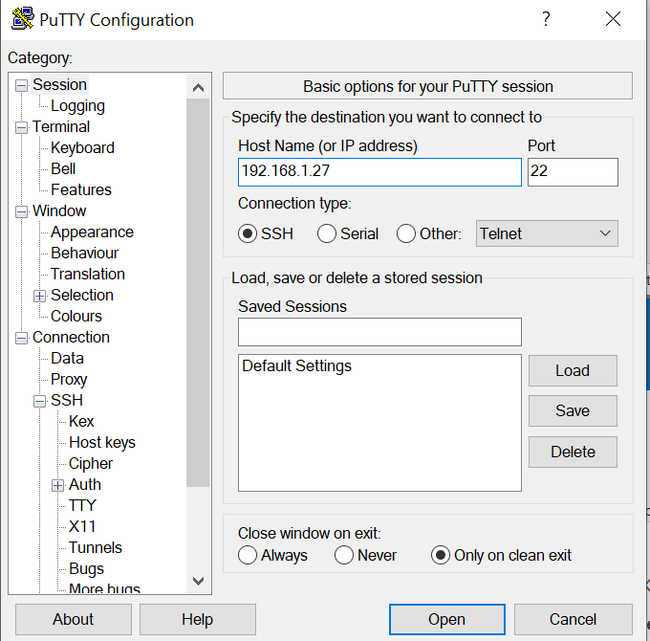

* 1. Click “**Open**” when you are ready to connect to your RPi. This must be on the same network that your host computer you are logging into is sitting on.
  2. On the first connection, you will receive a warning:

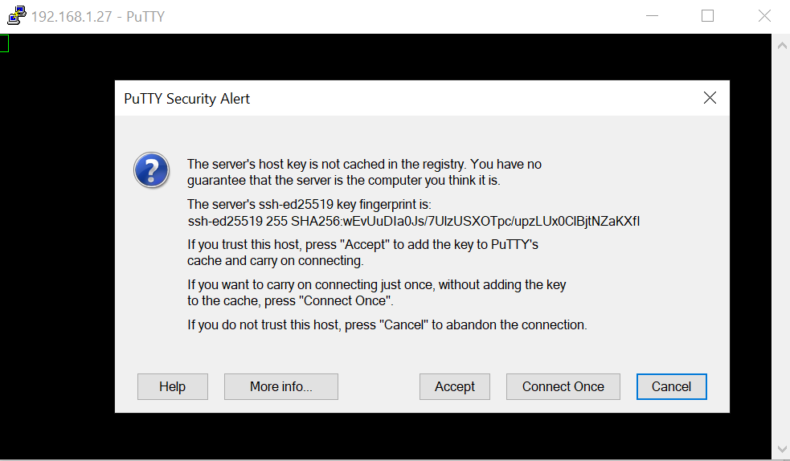

* 1. Click “**Accept**” to continue.
  2. Login for Kali: **user “kali”, password “kali”**

You now have a full remote text terminal through the secure shell (ssh). This is helpful to install packages (software) and start services.

Resources:

* <https://howchoo.com/pi/install-kali-linux-raspberry-pi>
* [https://www.offensive-security.com/kali-linux-arm-images/](https://nam04.safelinks.protection.outlook.com/?url=https%3A%2F%2Fwww.offensive-security.com%2Fkali-linux-arm-images%2F&data=04%7C01%7Cshannon.beck%40afacademy.af.edu%7C3fbea1cc99964810579208d9c6945f6d%7C7ab80a06f02945c084d17dad19ce3c61%7C0%7C0%7C637759162837809522%7CUnknown%7CTWFpbGZsb3d8eyJWIjoiMC4wLjAwMDAiLCJQIjoiV2luMzIiLCJBTiI6Ik1haWwiLCJXVCI6Mn0%3D%7C3000&sdata=tDc93lZSgZjs55Vo8PFTVCYiCjjDusBKPLvOvlwx4qI%3D&reserved=0)
* [https://www.kali.org/docs/introduction/download-official-kali-linux-images/](https://nam04.safelinks.protection.outlook.com/?url=https%3A%2F%2Fwww.kali.org%2Fdocs%2Fintroduction%2Fdownload-official-kali-linux-images%2F&data=04%7C01%7Cshannon.beck%40afacademy.af.edu%7C3fbea1cc99964810579208d9c6945f6d%7C7ab80a06f02945c084d17dad19ce3c61%7C0%7C0%7C637759162837809522%7CUnknown%7CTWFpbGZsb3d8eyJWIjoiMC4wLjAwMDAiLCJQIjoiV2luMzIiLCJBTiI6Ik1haWwiLCJXVCI6Mn0%3D%7C3000&sdata=amiBIvbHDGegAe4ATooB%2BZ3MXfA6lWwTWrUXIEmxJhQ%3D&reserved=0)
* [https://www.howtogeek.com/341944/how-to-clone-your-raspberry-pi-sd-card-for-foolproof-backup/](https://nam04.safelinks.protection.outlook.com/?url=https%3A%2F%2Fwww.howtogeek.com%2F341944%2Fhow-to-clone-your-raspberry-pi-sd-card-for-foolproof-backup%2F&data=04%7C01%7Cshannon.beck%40afacademy.af.edu%7C3fbea1cc99964810579208d9c6945f6d%7C7ab80a06f02945c084d17dad19ce3c61%7C0%7C0%7C637759162837809522%7CUnknown%7CTWFpbGZsb3d8eyJWIjoiMC4wLjAwMDAiLCJQIjoiV2luMzIiLCJBTiI6Ik1haWwiLCJXVCI6Mn0%3D%7C3000&sdata=8pzbKeGBN2TIO%2BPihtByrymQRvpmdyWSl%2FwO%2BhUHoFE%3D&reserved=0)
* [https://sourceforge.net/projects/win32diskimager/](https://nam04.safelinks.protection.outlook.com/?url=https%3A%2F%2Fsourceforge.net%2Fprojects%2Fwin32diskimager%2F&data=04%7C01%7Cshannon.beck%40afacademy.af.edu%7C3fbea1cc99964810579208d9c6945f6d%7C7ab80a06f02945c084d17dad19ce3c61%7C0%7C0%7C637759162837809522%7CUnknown%7CTWFpbGZsb3d8eyJWIjoiMC4wLjAwMDAiLCJQIjoiV2luMzIiLCJBTiI6Ik1haWwiLCJXVCI6Mn0%3D%7C3000&sdata=%2FyOIqBGo4GTsUn7%2Fww%2BTIM05ulhd1k7LMqy4Msh30co%3D&reserved=0)
* <https://www.balena.io/etcher/>
* <https://www.puttygen.com/download-putty>
* <https://stealthm0de.medium.com/enable-xrdp-on-kali-linux-506980a29d1d>